CS4650

Assignment 5: Watershed Segmentation

Alexander Kochman

November 8, 2024

**Abstract**

Watershed segmentation is an approach utilized within image processing to subdivide an image into distinct regions from a topographic perspective, in which each pixel's intensity resembles elevation. It helps to identify images or regions that overlap by considering boundaries where there is a steep change in intensity, so it is widely used in object detection and object segmentation tasks.

**Introduction**

Watershed segmentation, which is useful for resolving overlapping features, will be used in this project for the purpose of separating and looking at cell structures in grayscale images. The workflow focuses on delineating cellular outlines using K-means and watershed algorithms combined with binary masking, as well as labeling straightforward areas of interest and classifying the cells according to their size. The aim is to create a repeatable segmentation process which separates cells, allows measurement of the area of each cell, and permits evaluation of the size and positions of the cells within a section of the biological tissue.

**Results**

Original Images

Gray Images

Filtered Images

Glomus Watershed Results

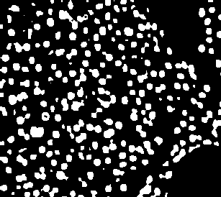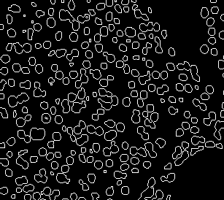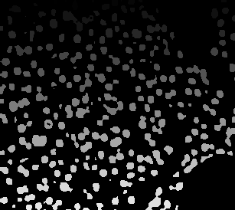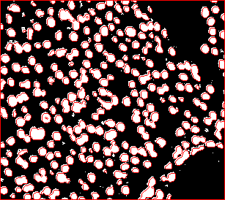

Metastatic Cancer Results

**Conclusion**

When segmenting cells in images like the ones provided, it can be difficult to differentiate the boundaries. Watershed segmentation attempts to remedy this issue by creating distinct boundaries that can be observed as an overlay on the original image. This allows for not only visual interpretation, but also statistical analysis, such as the area of the cells in these images. This method worked well for the glomus cell image because of the more distinctive nature of the cells. The metastatic cancer image benefited from this process, but some of the cells were still difficult to segment from each other because they appeared in such a connected manner. Nonetheless, watershed segmentation was a useful method to provide a more accurate analysis of an image.